Assignment2

Name: Ciarán Sweeney

Student Number:2838501

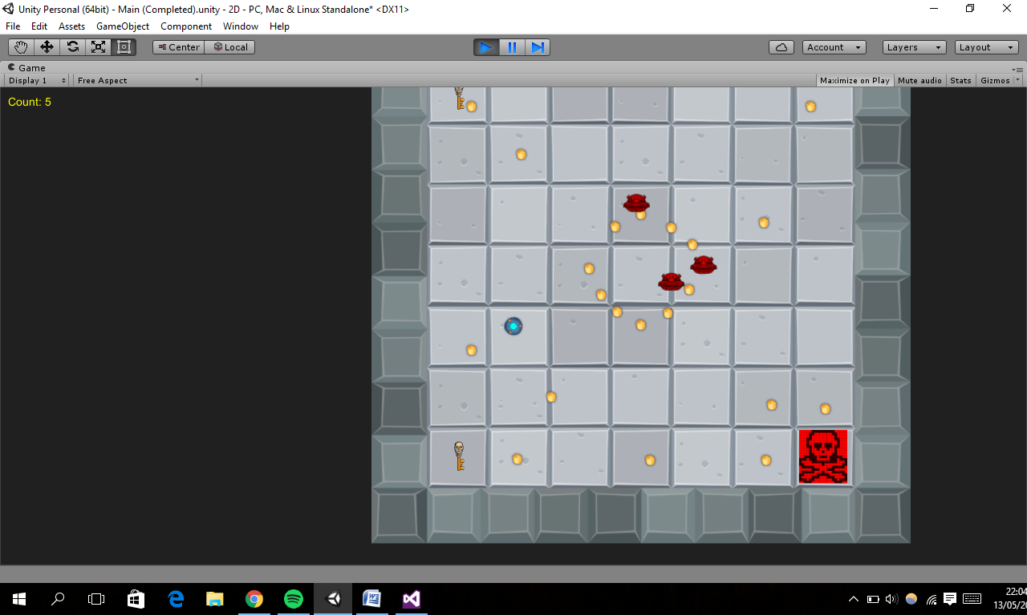

For this game the goal for the player is to collect all the points to collect and try to avoid the enemy AI. If the player hits the AI then the player dies and loses. For the enemy AI to kill the player, one of the agents must first get one of the Skelton keys and then bring it over to the kill zone. Once this is done the player can be killed and the enemy turns red, this lasts for about 10 seconds. Once the time is up the enemy’s must repeat the steps to kill the player. The agents AI are split into 3 types of jobs which are as follows active kill mode, chase player and guard points. The chase player works by simply chasing the player and guard points works by the agent going around each point individually. Each different job was given a value for example active kill mode was given a value of 1. The jobs were given to the agents depending on the distance from the player. The player furthest from the player had to go active kill mode while the player closest to the player had to chase the player. For the kill mode job the goapForKill() method used goal orientated action planning was used for which key the agent had to get and what the agent had to do once the key was in the kill zone. The cost of the agent receiving the key and bringing it to the kill zone for each key is first worked out in the goalForKill() method. The cost takes into account the distance of the agent to the key, also the key to the kill zone these costs are add up. The key with the lowest cost, its position will be added to a list of Vector3 called “goapOrder”. After the key position is added to the list then the kill zone position is added too. Once the agent reached every target on the “goapOrder” list then Goal orientated action planning is used again to work out the agent’s next step after activating the kill zone. This is done with comparing the amount of points left for the player to collect. If there is a low amount of points left the agent will be assigned the protection of points job otherwise the agent will chase the player. These jobs are updated every time kill mode has ended so after about 10 seconds kill mode has been activated. The scripts that are relative to look at and hard coded are AI, Killzone, KeyPickUp and Key. Most of the AI code is not surprisingly in the AI script.